Abhinav Sharma

ARIZONA RESEARCH LABS

Hardware Interlock setup: Synaccess NP-0201DU

Table of Contents

Checklist before setup: 3

Default Setting on the Hardware Interlock model Synaccess NP-0201DU 3

Configuring the IP address of the Interlock: 3

Interlock setup from iLab: 5

Hardware Interlock setup using

Synaccess NP-0201DU

# Checklist before setup:

1. Hardware Interlock device model – Synaccess NP-0201DU
2. **Identify the equipment and the subnet which can be accessed from the local ports in the facility**. This may be done along with the network manager of ARL or the building.
3. New IP address configuration for the interlock should be assigned before the setup.
4. Accessible power and network outlet near the equipment which is to be managed.

# Default Setting on the Hardware Interlock model Synaccess NP-0201DU

Username: admin

Password: admin

Network configuration-

Default IP: 192.168.1.100

Default Subnet mask: 255.255.0.0

Gateway: 192.168.1.1

# Configuring the IP address of the Interlock:

1. Connect the interlock to power and the network.
2. Open Network and sharing center -> Local Area Connection -> Properties -> Internet Protocol Version 4(TCP/IPv4)
3. Before changing the settings in the next step, keep a screenshot of settings for future reference.
4. Select Use the following IP address and change the network configuration to:

IP address: 192.168.1.2

Subnet mask: 255.255.255.192

Default Gateway: 192.168.1.1

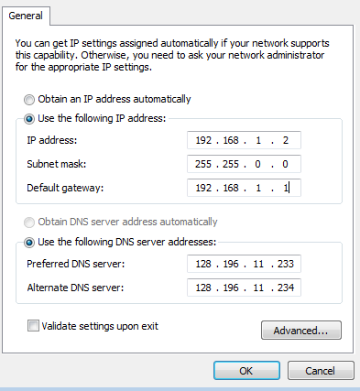

Note- Internet connection may be lost during this setup because of change in IP configuration.

1. Use internet explorer to open- 192.168.1.100 and enter login information as:
   1. User Name- admin
   2. Password- admin

And click OK.

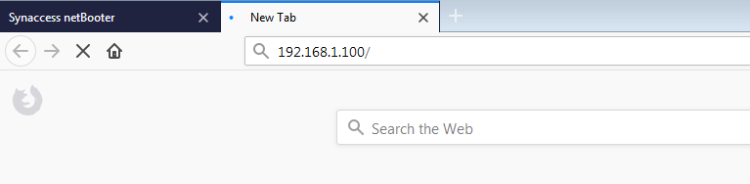

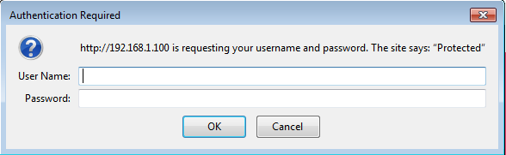

1. On log in, click on Network tab in the left pane (screenshot of the default configurations) and change the network setting as gathered from the Network Manager.

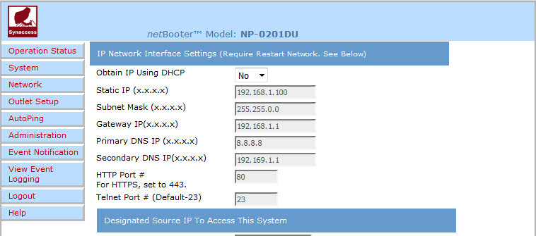

1. Change HTTP Port # to 443 as seen in the following screenshot.

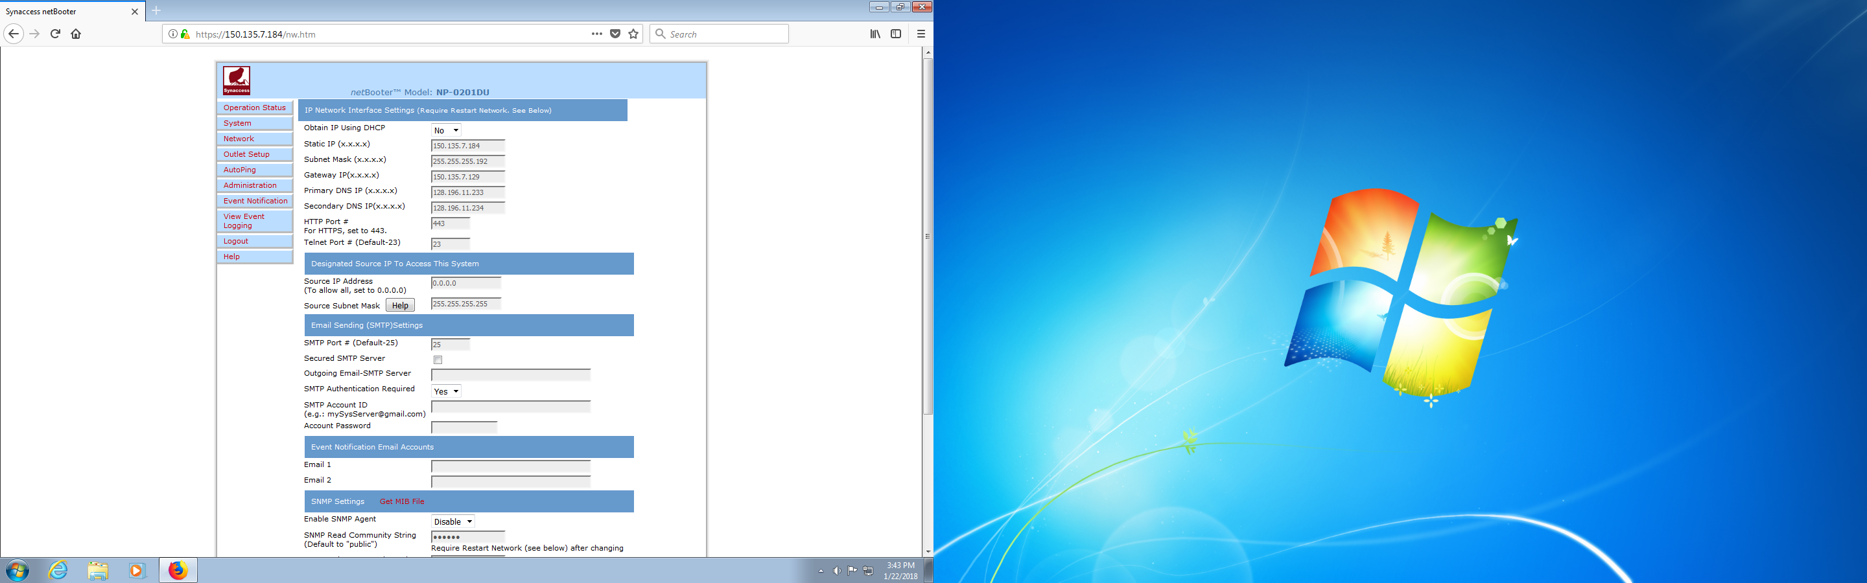

1. Click Save.
2. Revert back the network setting of your computer by opening Network and sharing center -> Local Area Connection -> Properties -> Internet Protocol Version 4(TCP/IPv4) and setting the network configuration as it was.

# Interlock setup from iLab:

1. Open ua.ilab.agilent.com and login from an administrator account.
2. Select the core facility from “my cores” for which the interlock needs to be implemented. Click on schedule equipment -> More dropdown -> Manage Interlocks

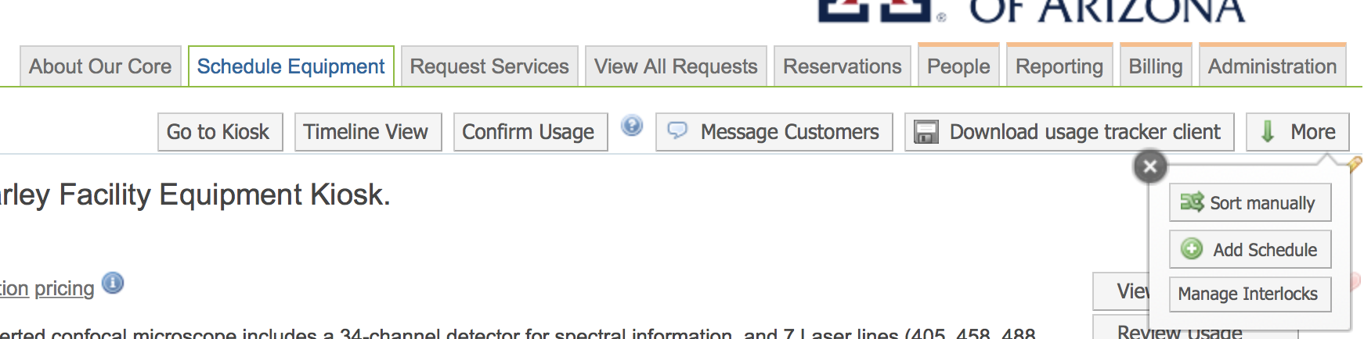

1. Click on Add New Interlock

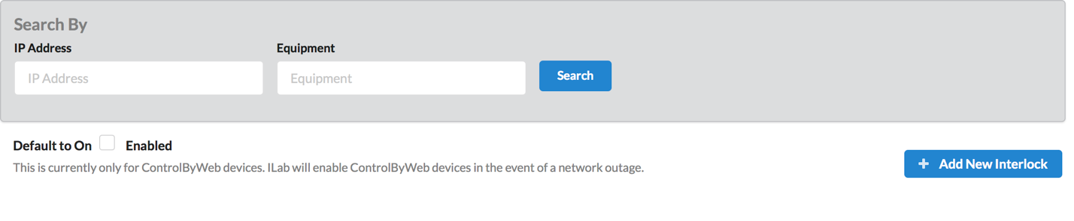

1. Enter the following configurations:
   1. Type- Synaccess NP-0201-DT
   2. Enter a Nickname following the convention – [Facility]-[Equipment]
   3. Select the iLab bridge
   4. IP Address as assigned by the network manager.
   5. Username and Password as admin
   6. Click Save.

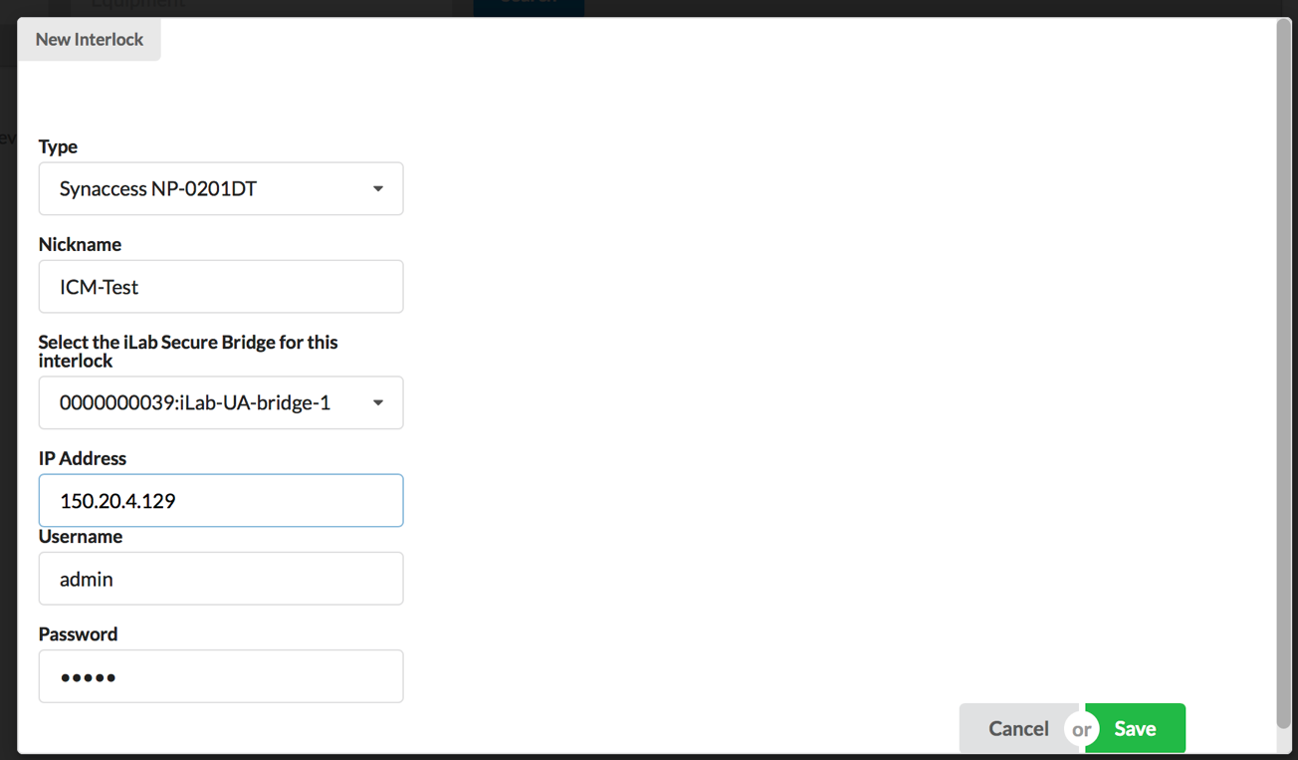

1. Click on the blue +(plus) sign at the first spot on the interlock and select equipment. Then press Blue -> (arrow) sign.

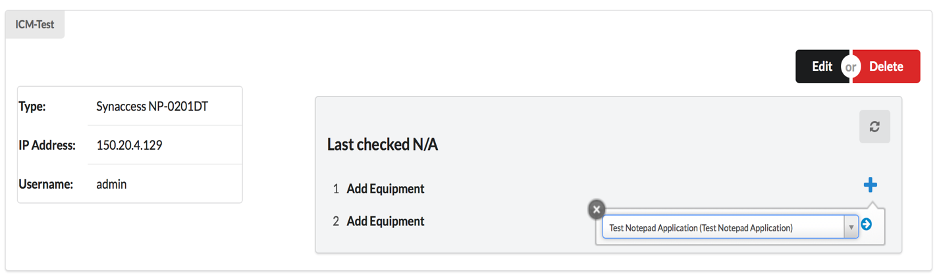

1. Configuration Confirmation:
   1. If correctly configured, the task will complete and Port 1 of the interlock will be managed by the iLab schedule.

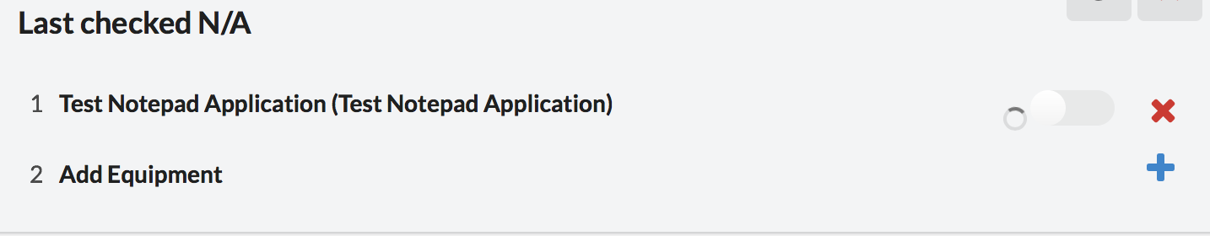

* 1. Else, an error message may be displayed which may inform about the hardware interlock IP not being correctly configured. Check the validity of IP address with the network manager before repeating Configuring the IP address of the Interlock steps.

